**Process Flow Diagram and Process Description**

*Process Flow Diagram*

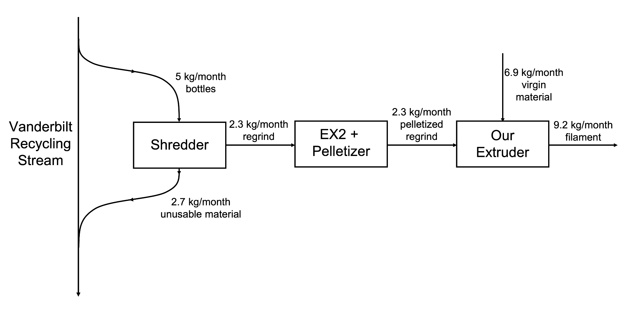

**Figure 1.** Process flow diagram for recycling PET from a slip stream via the Vanderbilt waste plastic stream. This diagram assumes a basis of 5 kg of PET bottles supplied by Vanderbilt Recycling.

*Process Description*

We are operating a slip stream from Vanderbilt’s primary recycled plastic stream with the goal of turning PET bottles into usable 3D printing filament. The process starts with receiving PET bottles from Vanderbilt Recycling. These bottles are then sorted by production origin (e.g. Coca-Cola bottles vs PepsiCo bottles) and shredded into rPET regrind. Thicker portions of the bottle, such as the curved bottoms and tops, and the bottle caps cannot be shredded; these are reintroduced to Vanderbilt’s plastics stream. The rPET regrind is then extruded through an Filabot EX2 to create filament that is then pelletized. These pellets are then fed into the student-built PET extruder at a ratio of 1:3 with virgin rPETG pellets creating our final product: Vanderbilt-sourced rPET filament.